**Church Roof Appeal**

St Peter & St Paul’s Church need YOU! We are fundraising to replace the Tower Roof and Organ Loft Roof and need your help please. Any donation you can make towards our goal will be very much appreciated. You can donate via cheque made payable to Wincanton PCC - in Church or The Parish Office at 38 High Street, or you can scan the QR code below. Please make sure your donation is clearly marked for the Roof Appeal. Contact 01963 824503 for our bank details if you prefer to donate via bank transfer. **Thank you!**



**Help us REACH THE ROOF!**

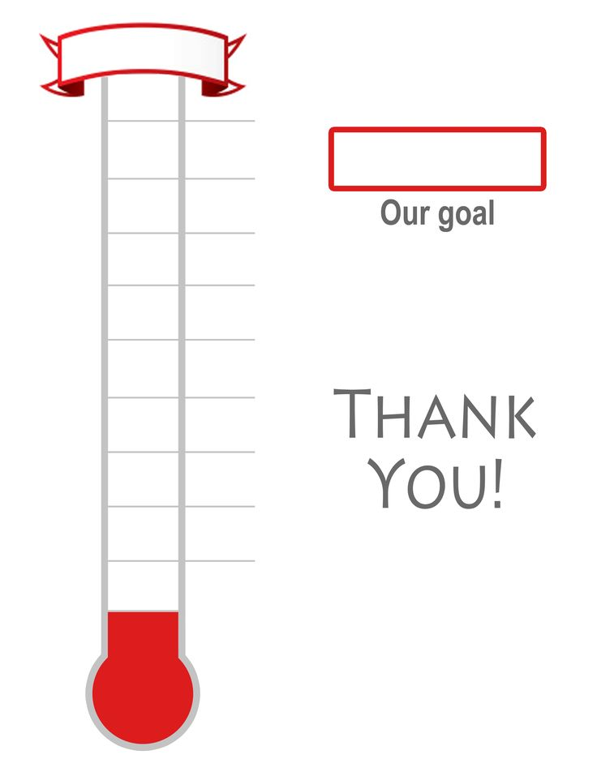

**£70,000**25,000

**£85,000**25,000

**Roof Appeal**

**£130,000**

**£10,000**

**£25,000**25,000

**£40,000**25,000

**£55,0000**25,000

**£100,000**,00025,000

**£115,000**,00025,000

**£130,000**,00025,000