*The Parish Churches of St. Peter & St. Paul, Wincanton*

*and St. Michael, Pen Selwood*

**

Church website: [www.wincantonparishchurch.co.uk](http://www.wincantonparishchurch.co.uk)

18th April 2021 3rd Sunday of Easter

Dear Friends,

This week we mark the death of His Royal Highness – the Duke of Edinburgh and our hearts and prayers particularly reach out to Her Majesty the Queen and all the Royal Family at this time of great loss. I have adapted some of the worship resources I have received in this regard, to make up a special resource for prayer and worship at home, which you will receive with this newsletter. This worship and prayer resource is available via a special page on our website with different aspects of how we are marking the passing of Prince Philip - <http://www.wincantonparishchurch.co.uk/?page_id=2118>.

I am grateful to all those who have rapidly attended to flags, tolling bells and various other important matters. On Friday this week, the eve of the funeral, both churches will be open for an additional session of private prayer. St Peter & St Paul’s Wincanton will be open from 2pm – 5pm and St Michael’s Pen Selwood from 10am – 3pm. There is a focal point remembering Prince Philip in each church (and also one in the parish office window). *You may wish to take the worship and prayer resource for this occasion with you if you attend a private prayer session in Church*.

Here is a prayer you may wish to use following the death of HRH the Duke of Edinburgh from churchofengland.org.

*God of our lives, we give thanks for the life of Prince Philip, for his love of our country, and for his devotion to duty. We entrust him now to your love and mercy, through our Redeemer Jesus Christ. Amen. -*

With love in Christ – Alison

**PS:** If you are finding the going tough at the moment, please don’t hesitate to ring Rev Alison. And if you would like to receive a regular phone call from the church team each week, do please get in touch.

**Bishop Peter’s farewell (taken from letter from the Bishop and archdeacons received 29th March).**

News from Bishop Peter and Jane is that they are home and +Peter continues to recover well. Plans for his farewell service on 22nd May are being worked on. We hope these will include the opportunity for as many as possible to gather online to say our ‘goodbyes’. We expect that many of you will want to give a gift or send a message. Please can you send messages to [andrea.howlett@bathwells.anglican.org](mailto:andrea.howlett@bathwells.anglican.org) by **Friday 14th May** and donations for a gift to the following:

Cheques:

Payable to The Bath & Wells Diocesan Board of Finance - Post to: The Bishops’ Office, The Bishop’s Palace, Wells, Somerset, BA5 2PD

BACS:

Account Name: The Bath & Wells Diocesan Board of Finance

Sort Code 60-23-06, Account Number 52161242, Reference **Bishop Peter** (Please ensure you put this reference when making the transfer)

**Readings for 18th April: Acts 3: 12-19 Luke 24: 36b-48**

**Readings for 25th April: Acts 4: 5-12 John 10: 11-18**

**Contact Details for Rev Alison Way -** Please note my contact details are:

Address: The Parish Office; 38 High Street, Wincanton, BA9 9JF

Landline: 01963 33151, Work mobile: 07515 958988

Email: [rector@wincantonparishchurch.co.uk](mailto:rector@wincantonparishchurch.co.uk), Twitter: @revalisonway

Facebook Group: Wincanton and Pen Selwood

In the coming week I will be off on THURSDAY

 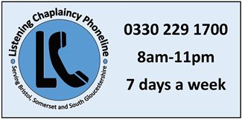

**The Parish Office** has had to close due to the continued restrictions placed on employers, due to the ongoing coronavirus pandemic. Rachel is working from home, during normal office hours: **Tuesday, Thursday & Friday mornings:**

**9:15am – 1:15pm.** You can contact Rachel on 01963 824503 or via email at: [office@wincantonparishchurch.co.uk](mailto:office@wincantonparishchurch.co.uk) business will continue as normal.

#### Church Diary * SUBJECT TO CHANGE AT SHORT NOTICE

**Wed 14th Apr 12:00 -2pm Wincanton Church open for Private Prayer**

**Fri 16th Apr 2pm - 5pm Wincanton Church open for Private Prayer**

**Fri 16th Apr 10am – 3pm Pen Selwood Church open for Private Prayer**

**Both churches are open on the eve of the**

**Funeral of HRH – the Duke of Edinburgh**

**Sun 18th Apr 10:00am Wincanton Church Public Worship Service**

**Sun 18th Apr 10am – 3pm Pen Selwood Church open for Private Prayer**

**Wed 21st Apr Wincanton Church CLOSED for Private Prayer – APOLOGIES**

**Sun 25th Apr 10:00am Pen Selwood Church Public Worship Service**

**Sun 25th Apr 9am - 11am Wincanton Church open for Private Prayer**

#### Church Notices

**St John, Chingola, our link church in Zambia**

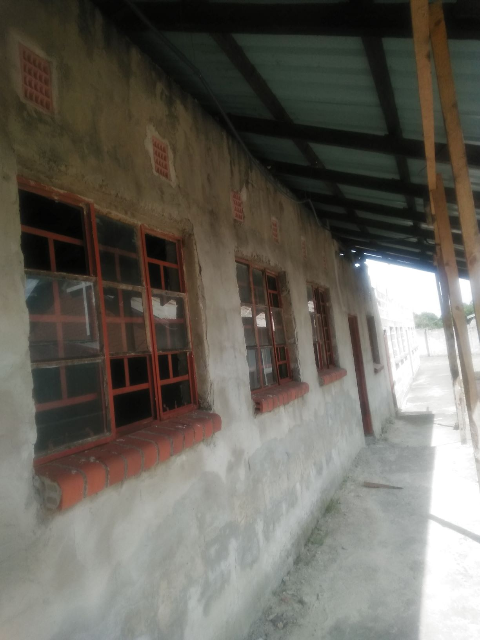





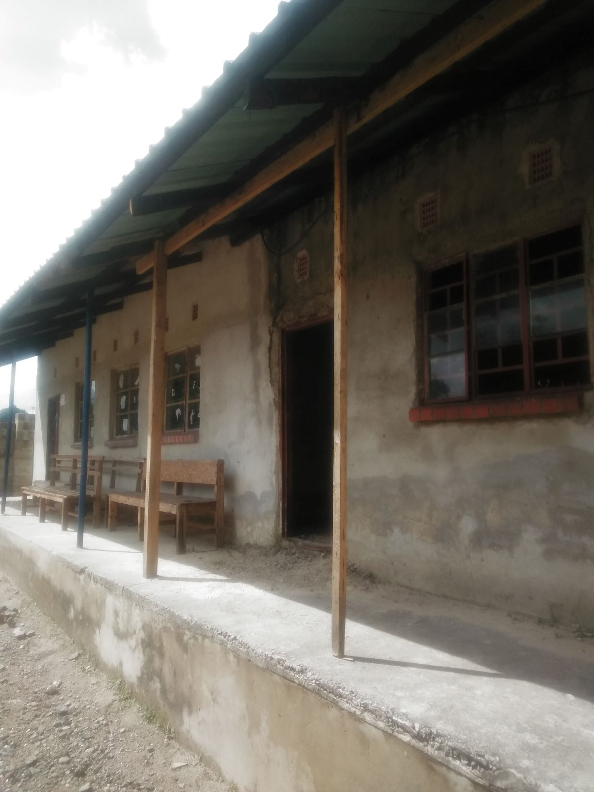

It is wonderful to receive these photographs from Father Chrissy Mumba at St John, Chingola showing their new classroom block with the roofing now on.  Thanks to your generosity through quarterly giving, Lent lunch and Lent boxes, we have been able to send money to St John for them to buy the roofing sheets and complete the building so that it can be used for the Christian education of their children. **Rosemary Keep.**

**Prayer List –** If you would like to be added to our Prayer List, or feel a friend or relative should be on our Prayer List, please do let me know. If you are wanting someone else to be prayed for you must have their permission.

Anybody is welcome to be included in our prayers at any time, and I will also pray for you in my daily prayers. Please use the contact details in this newsletter to contact me. **Alison.**



**Prayer Diary**

**From today’s readings:** “Jesus himself stood among them and said to them, ‘Peace be with you.’ They were startled and terrified, and thought that they were seeing a ghost. He said to them, ‘Why are you frightened, and why do doubts arise in your hearts? Look at my hands and my feet; see that it is I myself. Touch me and see; for a ghost does not have flesh and bones as you see that I have.’ And when he had said this, he showed them his hands and his feet.”.

**Prayer Chain:** If you would like immediate prayers for yourself or someone you know please contact one of the following (requests passed in confidence): Penny Ashton 33990 or Judy Chiplen 33834. If you wish to join the prayer chain, contact Judy 33834. If you wish to be added to our Prayer List, please contact Rev Alison Way 33151.

**Please continue to pray for** those of our fellowship and friends whoare ill or recovering from operations: Derek Ayers, June and Steve Beech, Margaret Brown (Gwen Evans’ Daughter), Irene Rix (Sue Hall’s Mum), Ann and Bryan Phillips, Sam (Gill Oaten’s Great Great Nephew), Joyce Bentley, Mike Gray, Sue Cox, Brenda Piper, Bishop Peter and Jane Hancock, Canon Alan and Rosemary Watson, Elizabeth Vivyan, Elroi Manor, Gwen Evans.

**Please remember** the long-term sick, the housebound & their carers.

**Please pray for those who grieve, and for the departed:** Patricia Mary Lampert, Joan Croft (prayers for Nicky King & family), His Royal Highness – The Duke of Edinburgh (prayers for Her Majesty the Queen & royal family)

We pray for Wincanton Health Centre and Wincanton Community Hospital, for the staff in their work pressures.

**Food for thought and prayer** - We will be looking for another churchwarden to accompany Sue, from **April** for St Peter and St Paul. Please give this your consideration and prayer.

*Parish Office: 38 High Street, Wincanton BA9 9JF 01963 824503*

*Any items, for inclusion the Newsletter, to Rachel by midday on Wednesday.*

*Email:* [*office@wincantonparishchurch.co.uk*](mailto:office@wincantonparishchurch.co.uk)