What to expect when attending St Peter and St Paul Wincanton for worship MARCH 2021
Christ is our peace. He has reconciled us to God in one body by the cross. We meet in his name and share his peace.
cf Ephesians 2.15,16
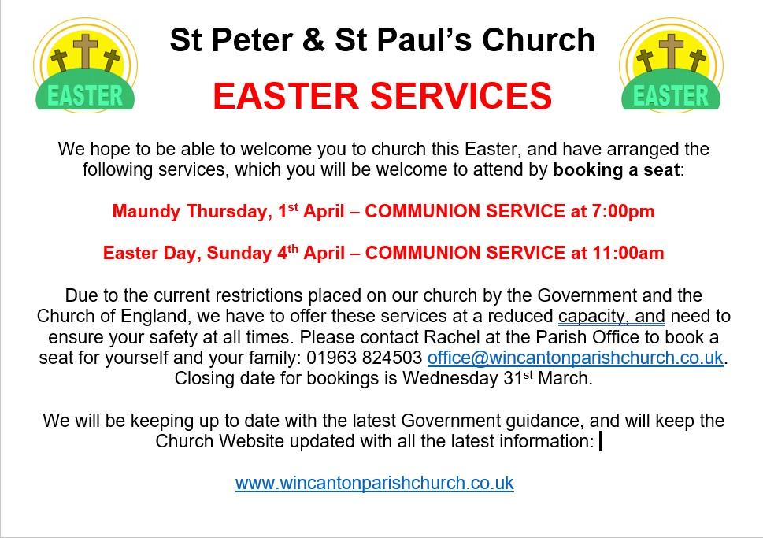
Preparing to come
- For some services it will be necessary to book a few days ahead so we can best fill the available space inside the building or provided sufficient socially distanced seating outside.
- It is your decision whether you should be coming to worship at this current time based on your wellbeing. Please be across the latest Government guidance for you, particularly if you are in a vulnerable or extremely vulnerable group.
- If you have any symptoms associated with Coronavirus or are self-isolating, please do not attend church for public worship. (If you have booked a place, please let us know so we can offer your place to someone else).
- Please bring with you anything you may need (no shared resources will be available – kneelers, cushions, books, toys).
- Face coverings are required unless you have a valid exemption.
- Please bring a small pot of hand sanitiser with you if you intend to receive communion.

Arriving
- Come to the South Door of the church.
- (If this is a service with booking) someone outside will check your booking
- If you are using the NHS track and trace app please scan the QR code which will be on an outside noticeboard by the door. If not, please bring a slip of paper with your name and phone number which will be kept for 3 weeks for tracking and tracing purposes.
- Please sanitise your hands on entry and follow the one-way systems in place.
- Put any offering you may wish to give on the plate by the entrance.
- Due to current restrictions ‘you must not socialise with people from outside of your household or support bubble while you are indoors there.’ This will only change when the ‘Rule of Six’ applies inside currently provisionally 17th May. Also after March 29th it will be possible to socialise outside within the confines of the ‘Rule of Six’ if it is in place by then.
- Help will be at hand to guide you to your pre-allocated booked seats.
- Please stay in your seat and prepare to worship quietly only socialising within households or household bubbles.

Worshipping
- Please speak quietly when giving responses.
- Congregational singing is not allowed currently – so any music included will be played or recorded. A soloist may sing also suitably socially distanced from the congregation and in keeping with guidance for indoor singing. communion.
- Hands must be sanitised immediately before receiving communion.

Leaving
- Please take the order of service you have handled home with you for disposal.
- Please leave the church quietly as directed by one of the wardens at the end of the service via the South Door.
- Please sanitise your hands on exit.

Sources of the guidance – if you wish to read for yourself are: -
https://www.gov.uk/government/publications/covid-19-guidance-for-the-safe-use-of-places-of-worship-during-the-pandemic-from-4-july/covid-19-guidance-for-the-safe-use-of-places-of-worship-from-2-december
https://www.churchofengland.org/more/media-centre/coronavirus-covid-19-guidance-churches
If you wish to discuss aspects of this – please get in touch with Alison in the first instance. She should be able to explain our reasoning – but has no control over what the guidance from the Government / Church of England requires of us. For all our safety in these challenging times, we need to work within the confines of this guidance.
New Revised Standard Version Bible: Anglicised Edition, copyright © 1989, 1995

