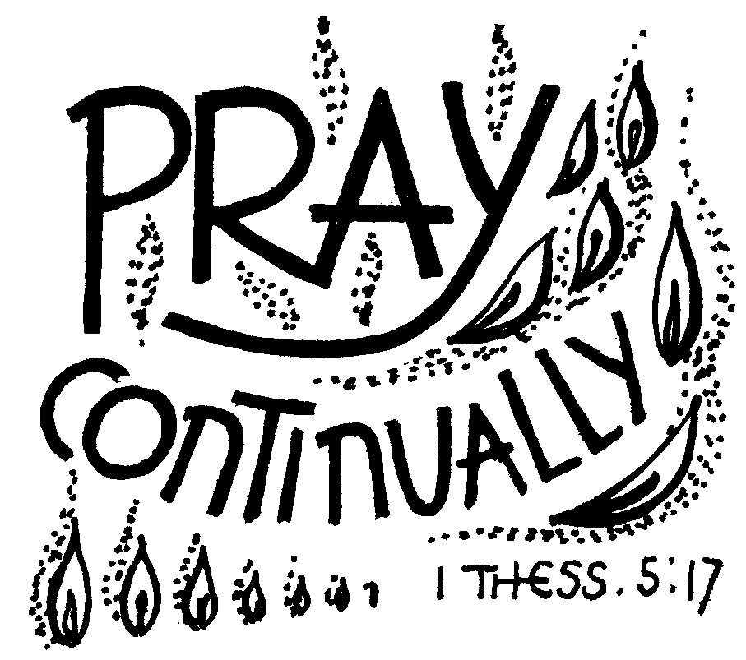
Daily Prayer for use in Wincanton and Pen Selwood

22nd – 28th March 2020

Preparation
O God, make speed to save us.
All O Lord, make haste to help us.
Hear my prayer, O Lord, and give ear to my cry;
All hold not your peace at my tears.
Psalm 39.13

Praise
Jesus, like a mother you gather your people to you; you are gentle with us as a mother with her children.
Despair turns to hope through your sweet goodness; through your gentleness we find comfort in fear.
Your warmth gives life to the dead, your touch makes sinners righteous. Lord Jesus, in your mercy heal us; in your love and tenderness remake us.
In your compassion bring grace and forgiveness, for the beauty of heaven may your love prepare us.
Anselm (1109)
The Word of God
Psalms
MONDAY Psalm 3, TUESDAY Psalm 6, WEDNESDAY Psalm 11, THURSDAY Psalm 12, FRIDAY Psalm 69.1-13, SATURDAY Psalm 61

Short Reading
MONDAY, Joel 2.12-14, TUESDAY I Corinthians 9.24-end, WEDNESDAY Romans 7:21-25a, THURSDAY Isaiah 58:6-9a, FRIDAY Romans 5.6-8 SATURDAY Luke 10.38-end

Blessed are the merciful,
All for they will receive mercy.

Prayers
Let us pray to God,
who alone makes us dwell in safety:
For all who are affected by coronavirus,
through illness or isolation or anxiety,
that they may find relief and recovery:
Lord, hear us,
All Lord, graciously hear us.
For those who are guiding our nation at this time, and shaping national policies,
that they may make wise decisions:
Lord, hear us,
All Lord, graciously hear us.
For doctors, nurses and medical researchers, that through their skill and insights many will be restored to health:
Lord, hear us,
All Lord, graciously hear us.
For the vulnerable and the fearful,
for the gravely ill and the dying,
that they may know your comfort and peace: Lord, hear us,
All Lord, graciously hear us.

Silent prayer or a time of open prayer

We commend ourselves, and all for whom we pray, to the mercy and protection of God. Merciful Father,
accept these prayers
for the sake of your Son,
our Saviour Jesus Christ.
Amen.
Teach us, good Lord, to serve you as you deserve; to give and not to count the cost;
to fight and not to heed the wounds;
to toil and not to seek for rest;
to labour and not to seek for any reward,
save that of knowing that we do your will.
All Amen.
The Lord's Prayer is said.
All Our Father in heaven, hallowed be your name, your kingdom come, your will be done, on earth as in heaven. Give us today our daily bread. Forgive us our sins
as we forgive those who sin against us.
Lead us not into temptation but deliver us from evil. For the kingdom, the power,
and the glory are yours now and for ever.
Amen.

The Conclusion
May God bless us and show us compassion and mercy.
All Amen.
Copyright acknowledgement Some material included in this service is copyright: © The Archbishops' Council 2000-2020

Worship Suggestions 18th March 2020
There are a range of Christian resources already available:
- The BBC's Daily Weekday Service 9:45am on Radio 4 Longwave
- The BBC’s Sunday Worship – 8:10am on Radio 4
- BBC’s Songs of Praise Sunday 13:15 on BBC1
- Live streaming services - users can watch live streams of services from a range of churches and we will be improving AChurchNearYou.com in the days ahead to make this clearer.
  - All Hallows by the Tower
  - Buckingham Parish Church
  - St Nicholas Church, Canvey Island
  - St James' Church, Clitheroe
  - St Mary's Kenton
- #LiveLent: Care for God's Creation - the Church of England's Lent campaign for 2020. With weekly themes shaped around the first Genesis account of creation, it explores the urgent need for humans to value and protect the abundance God has created. This daily audio content is available via the app and daily emails. Sign up for free.
There are various suggestions here for prayers and worship specifically for the current circumstances that can be used
https://www.churchofengland.org/more/media-centre/coronavirus-covid-19-liturgy-and-prayer-resources

