**Community Notices**

**Black Bin Café: (the same day as black rubbish bins are emptied)**

This is held in Pen Selwood Village Hall every other Friday from 10-30am - 12 midday. If you have not visited this then please do go along. It is a wonderful social event and well worth a visit.

**Foresters Friendly Society -** Friday 21st June Summer Outing, to Poundbury Garden Centre & Weymouth. For further details or to book please Tel: 01963 33160 Many thanks, Richard.

**There will be a theatre performance** of "The Hiding Place", the story of Corrie Ten Boom, at Wincanton Community Church on Sat June 8th at 7.00pm. tickets are £10 in advance from the Community Church or [oddments-theatre.co.uk](http://oddments-theatre.co.uk/).  Corrie and her family were clock makers in The Hague who hid many Jews from the occupying Nazis before being discovered.  Corrie survived Ravensbruk and after the war had a wonderful ministry preaching forgiveness and reconciliation.

.** Prayer Diary**

**From today’s readings:** “Just as I have loved you, you also should love one another”

**Prayer Chain:** If you would like immediate prayers for yourself or someone you know please contact one of the following (requests passed in confidence): Penny Ashton 33990 or Judy Chiplen 33834. If you wish to join the prayer chain - contact Judy 33834.

**Please continue to pray for** those of our fellowship and friends whoare ill or recovering from operations: Pearl Ayers, June and Steve Beech, Margaret Brown, Molly Carr, Eric Devonshire, Francis Dukes, Rebecca Legg, Peter Lewis, Ben Legg, Ken Madely, Ern Oaten, Diana Paley, Mavis Paley, Anne Phillips, Brian Phillips Ben Sams, Sheila Watkins, Kath White, Robin Wickenden, Kevin, Sally and for their carers.

**Please remember** the long-term sick; the housebound & their carers.

**Please pray for those who grieve, and for the departed:**  Miranda Collins and Jo Civale.

We pray for Wincanton Health Centre, for the staff in their work pressures.

*Parish Office Hours: Tues, Thurs & Fri: 8.30am -12. 00 noon 38 High Street, Wincanton BA9 9JF. Tel: (01963) 824503*

*All items, for the Newsletter, to the Parish Office by 5pm Thursday at the latest. Email:* [*office@wincantonparishchurch.co.uk*](mailto:office@wincantonparishchurch.co.uk)

*The Parish Churches of St. Peter & St. Paul, Wincanton*

*and St. Michael, Pen Selwood*

**

Parish Office: 01963 824503

Church website: [www.wincantonparishchurch.co.uk](http://www.wincantonparishchurch.co.uk)

May 19th 2019 5th Sunday of Easter

**Services Today:**

Welcome

**Pen Selwood** 9.00am Holy Communion Rev K Masters

**Wincanton** 10.30am Holy Communion Rev H Jalland

**Readings: Acts 11: 1 - 18 John: 13: 31 - 35**

**Please join us for tea and coffee after the services marked\***

A loop system operates at both churches. Large print publications are also available – please ask for them. ‘Play bags’ are available for youngsters in the play corner at Wincanton. A public toilet is available just up the road on the right-hand side at Wincanton. At Pen Selwood toilet facilities are in the adjacent village hall (please obtain the key from a sides-person / helper).

**Sunday 26th May 6th Sunday of Easter**

**Pen Selwood** 6.30pm Evensong

**Wincanton** 10.30am Holy Communion

***Please take a copy of this newsletter to a friend or neighbour who is not in church today so that they may keep in touch with events***

**Worship Notes:** Today we welcome Rev Hilary Jalland at Wincanton and Rev Ken Masters at Pen Selwood to celebrate Holy Communion. We also offer a very warm welcome to our congregation and all visitors to both churches. At Wincanton today, after the service, we welcome Poppy Turvey and her family for her Baptism.

**Quote of the Week**

“Let God’s promises shine on your problems.” –**Corrie ten Boom**

#### Church Diary

Mon 20th May 9.00am Tiny Church

Tues 21st May 7.30pm Bell Ringing Practice

Thurs 23rd May 1.00pm Lunchtime Prayer for the vacancy

7.30pm Choir Practice

#### Church Notices.



***Coffee Morning***

***Saturday June 8th 2019***

***In the Memorial Hall Sun Lounge Wincanton***

***10.00am - 12 noon***

***Cakes, Produce, Raffle, Books.***

***Come along and have a chat and***

***enjoy the social atmosphere***

#### Ascension Day Service: Thursday May 30th at 7.00pm

at Queen Camel Church. A Deanery Eucharist with the

Commissioning of Matt Ireland, as Schools Chaplain. (Matt was a former pupil of King Arthur’s School). Guest Preacher: Revd Mike Haslam Diocesan Chaplaincy Enabler. All are welcome at this service, please put this date in your diary.

**Administrator - Parish Church Office -** We are pleased to confirm that Rachel Feltham who will be taking over from Gill, has now started in the Parish Office. Please do come in and say hello to Rachel when passing.

**Sides-person:** We are looking for a volunteer to become a sides-person on the 3rd Sunday of every month. June Spencer has decided to retire from this position. We thank June for her continued support and wish her well. If you feel you would like to help please see the churchwardens.

**Dairy Dates:** 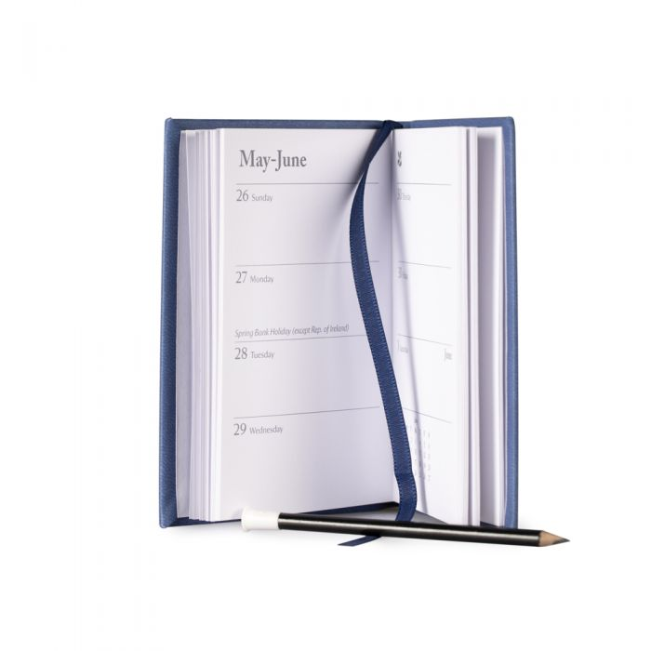

June 8th Coffee Morning

July 13th Church Fete and Coffee Morning in Church

August 10th Coffee Morning and Nearly New Clothes

September 14th Coffee Morning and Sponsored Knit

October 12th Coffee Morning

November 9th Christmas Fayre Coffee Morning

November 30th Christmas Bingo at The Bear Inn

December 14th Christmas Coffee Morning in Church

**Fundraising at Wincanton church**

The next coffee morning is on June 8th.

On Sat July 13th we are holding our Church Path Fete. We would be grateful for prizes for the raffle and tombola, jewellery for the jewellery stall and bottles of wine for the Water or Wine stall. If you can help us with any of these items please see the churchwardens or take them to the office.

At the August 10th Coffee Morning, we are holding a sale of nearly new clothes in the Memorial Hall. Again if you have items for us to sell please see the churchwardens or take to the office.

All profits from these events go to boost church funds. Thank you.

**Zambia Link:** Thank you for monies raised at Lent Lunch, through the Lent Boxes and the Good Friday church service. A total of £434.08 was raised. Very many thanks to all who supported this worthy cause. Rosemary.

**Church Usage:** If you wish to use the parish Church for events, group meetings or similar, please ensure that any such requirement is entered into the diary within the Parish Church Office. This can be done by either calling into the office, phoning the office or email. This will ensure that there is no duplication of bookings. Thank you for your assistance.